***1.***

IP 10.1.5.65 because it has the longest subnet mask that still includes the destination IP. Therefore, the router would send the packet to the interface associated with the 10.1.5.64/29 network, which is s0.

***2.***

2. This is because the packet's destination address 131.23.151.76 falls within the range of the prefix 131.19.0.0/16.

***3.***

1) Next hop is D

2) Next hop is B

3) Next hop is D

***4.***

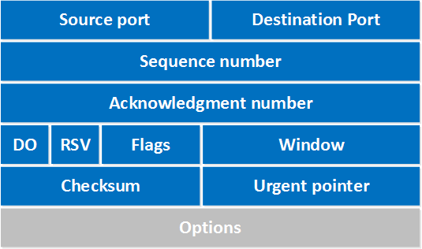



*Frame:* 34th packet of the capture, 54 bytes on wire, 54 bytes captured

*Ethernet:* Source MAC address of the sender, Destination address on the local network

*IPV4:* IP Address that send the packet, Destination IP Address

*TCP:* Port number of the sending app, port of the receiving app, Sequence num (for keeping track of data order), Ack acknowledges the receipt of data and indicates the next sequence number expected, Len is the length of the payload which is 0 in the above case.

***5.***

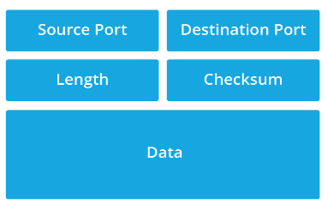

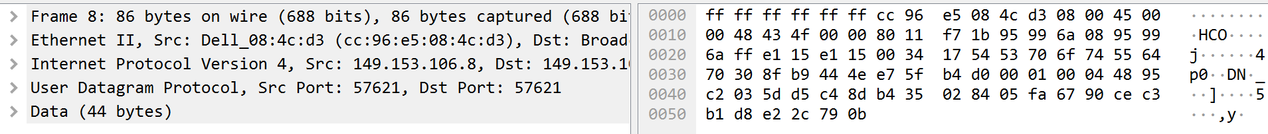

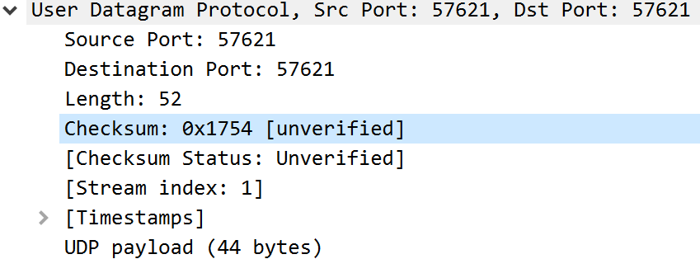

Source port is 57621

Destination port was the same

Len was 52

Checksum is shown above

Biggest difference between UDP and TCP is that UDP doesn’t guarantee delivery, ordering, or even duplicate protection which makes it faster and simpler.